**Issues executing pre-commit hook with Anaconda’s python path**

* **Why:**

We’re trying to execute pre-commit hooks on SQL scripts that get uploaded to our github repository via DataGrip. We’re using pre-commit python package and implemented the hook with .pre-commit-config.yaml file and our python scripts.

* **What I did:**

I have installed pre-commit through Anaconda’s terminal and placed the .pre-commit-config.yaml in my repository with the necessary python scripts. After running *pre-commit install* command on conda terminal it created the pre-commit hook file in .git/hooks/ folder, the python path in front of INSTALL_PYTHON= in the pre-commit hook is Anaconda’s python path, everything works well till this step, but once I try to commit any changes with this setup on (Using Datagrip for commiting), I get an error in DataGrip (error screenshot attached below). However, if I change the python path in pre-commit file to the python3 directory, where I’ve installed python3 directly through [https://www.python.org/downloads/] the pre-commit hook works as expected and executes all the scripts I configure in the .yaml file with the expected output.

* + OS – Windows 10 Enterprise
  + Terminal – Conda terminal through DataGrip
  + Python version in Anaconda – 3.9.12
  + Python3 version in system – 3.10.7
  + Pre-commit version – 2.20.0

**Error:**

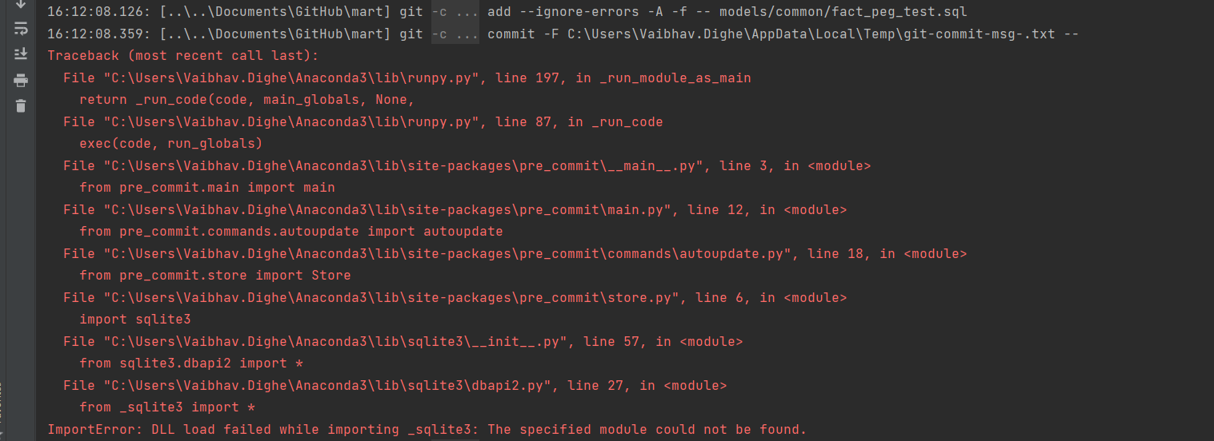

**.yaml file:**

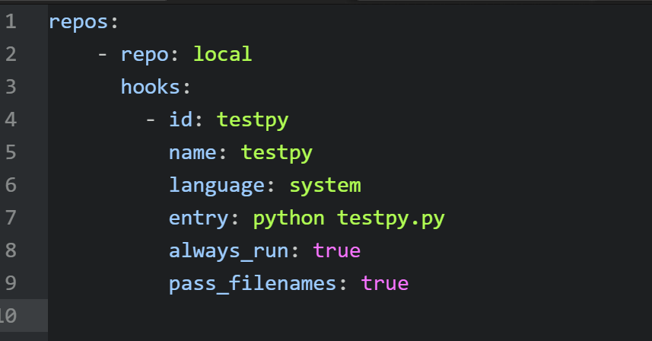

The testpy python file just has a small code which prints out the arguments passed by the system.

Anaconda’s python path which causes the errors:

Python path where hooks execute successfully:

* **What I expect:**

When I generate the pre-commit hook using *pre-commit install* command from conda terminal (where the file has Anaconda’s python path), I expect to see the hooks execute and show the relevant passed/failed status as it is showing when I change the python path manually in pre-commit file to python3 installed in the system as shown above.

* **What happened:**

Screenshot of the error I’m getting with Anaconda’s python path in pre-commit file is attached above.